Project Development Phase

**Sprint 3**

|  |  |
| --- | --- |
| Date | 15 November 2022 |
| Team ID | PNT2022TMID27760 |
| Project Name | AI Based Discourse for Banking Industry |

Screenshots of Sprint 3 Tasks:

Build Python Code:

1. 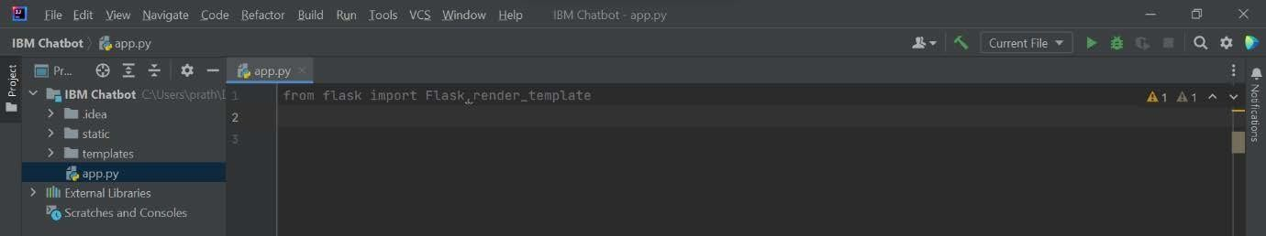**Importing Libraries**
2. **Creating our flask application and loading**

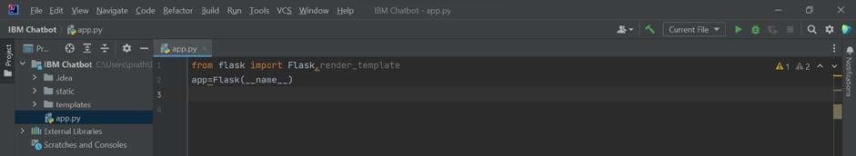

1. **Routing to the HTML Page**

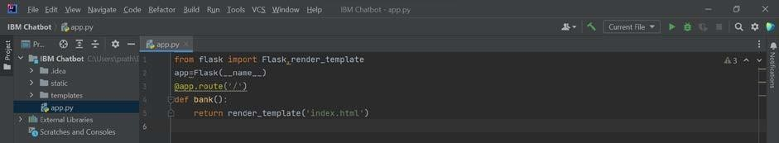

1. **Main Function**

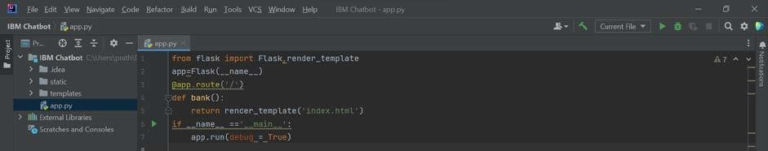

Run the Application:

